**Journal of Science and Technology**

**© 2023 Kwame Nkrumah University of Science and Technology (KNUST)**

**RESEARCH PAPER**

**IMPACT OF KNUST ON LAND USE CHANGES IN KOTEI AND AYEDUASE**

**Nathaniel Lartey, Emmanual Akrofi, and Elisha Anankansa\***

*Department of Geomatic Engineering, Kwame Nkrumah University of Science and Technology*

**\*Corresponding author: nathanielnolartey@gmail.com**

# ABSTRACT

*This study investigates the Impact of Kwame Nkrumah University of Science and Technology (KNUST) on land use changes in the neighboring communities of Kotei and Ayeduase. Over a three-decade period from 1990 to 2020, we explore the complex interplay between university growth, population expansion, and their socio-economic consequences in these areas. Employing a comprehensive approach, we utilized Geographic Information System (GIS) and remote sensing techniques to analyze land use changes in the study area over the specified time frame. Through GIS, we mapped and tracked the expansion of built-up areas, shifts in vegetation zones, alterations in wetlands, and fluctuations in barelands. Additionally, remote sensing data aided in the identification of land cover changes. R programming was employed for data processing and statistical analysis to uncover correlations between student population dynamics and land use changes. The analysis of land use changes reveals significant shifts. Built-up areas experienced rapid urbanization from 1990 to 2000, with a remarkable surge of 199.01%. This trend continued but at a slower pace in the subsequent decade (17.78%). By 2020, the built-up area had reached 1804.89 hectares. Conversely, vegetation zones exhibited fluctuating patterns, while wetlands dwindled significantly by 63.91% by 2010. Barelands displayed dramatic fluctuations, shrinking, surging, and then decreasing again. Our findings underscore the intricate relationship between KNUST's growth, land use changes, and their socio-economic consequences in Kotei and Ayeduase. While economic opportunities and job creation emerge as positive outcomes, there are also challenges associated with cultural heritage preservation, resource strain, and environmental degradation. The encroachment of wetlands and the expansion of built-up areas raise concerns about biodiversity loss and increased vulnerability to flooding. These findings highlight the need for sustainable and inclusive development strategies that balance economic growth with socio-cultural preservation and environmental sustainability in these communities.Top of Form*

**Keywords:** Land use changes, Geographic Information System (GIS), Remote sensing techniques, Population dynamics, Environmental sustainability, Urbanization, Kotei, Ayeduase

.

# INTRODUCTION

Changes in land use are an important part of environmental studies because they show the dynamic interplay between human activities and the natural environment. This transformational process is frequently a mirror that reflects regional economic functionality and developmental trajectories (Ross, Kaiser, and Mazaheri, 2017). Higher education institutions have emerged as essential organizations in this multidimensional interplay, holding enormous influence over land use changes. Through their objectives, activities, and decision-making processes, these institutions serve as catalysts for significant social and economic transformations in their surrounding areas (Teig et al., 2009).

The goal of this research is to rigorously explicate the impact of Kwame Nkrumah University of Science and Technology (KNUST) on the land use dynamics in the neighboring towns of Kotei and Ayeduase. The presence and expansion of the university have far-reaching consequences acting as a crucial catalyst for both social and economic transformations in these locations (Addie, Keil, and Olds, 2015). The study seeks to delve deeply into the evolution of land use and population dynamics in these locations, demonstrating the numerous ways in which KNUST has affected their physical, socioeconomic, and environmental environments through time.

This study employs geospatial technologies such as GIS and remote sensing to capture precise and timely spatial changes in land use/land cover (LULC) and to aid in ecological management and strategic environmental planning (Liping et al., 2018).

These methodologies, combined with the comparative analysis of satellite imagery and the deployment of land classification models, provide a layered and nuanced understanding of land-use changes over different time scales, revealing KNUST's subtle and profound influence on these changes (Casana, 2020). KNUST's evolution is more than just academic advancement; it is also an active agent for scientific, technological, and industrial advancement in the region. The influence of such progress is visible in the remarkable transformation of nearby communities such as Ayeduase and Kotei. Historical analyses and longitudinal studies demonstrate a significant transition of these formerly rural areas into dynamic urban zones. This transition is supported by rising urbanization rates, technological developments, and commercial expansion, all occurring concurrently with the expansion of KNUST (Korah et al., 2017).

This study is founded on the solid theoretical foundations of Urban Land Use Theory and Innovation Diffusion Theory. These theoretical views enable the study to conceptualize how academic institutions, such as KNUST, act as catalysts for changing economic, cultural, and infrastructural landscapes and transforming land use paradigms in their surrounding communities. The transformation in these places reflects a considerable decline in agrarian landscapes, as well as a significant increase in infrastructure developments, commercial proliferation, and residential expansions (Butt, 2013).

KNUST has reshaped and redefined the socioeconomic areas of Ayeduase and Kotei, as evidenced by an increase in employment opportunities, a rise in property values, and consequential displacements, altering demographic compositions and reshaping livelihood strategies (McCusker & Carr, 2006).

The interrelationship of environmental sustainability and land use changes is a critical component of this study, with considerations given to biodiversity loss and changes in local climate due to the regions' expansive growth (Lambin et al., 2001). While numerous studies have investigated the various dimensions of land use and cover changes (LUCC) in various regions of Ghana, there is still a discernible gap in understanding the nuanced impacts of tertiary institutions like KNUST on adjacent land use, particularly in regions like Kotei and Ayeduase (Korah et al., 2017).

By bridging this gap, this study aims to investigate how the existence and practices of such institutions influence the socioeconomic, environmental, and developmental aspects of nearby communities, with a particular emphasis on agricultural land availability, local livelihoods, and community well-being. This study, which draws similarities with global instances such as Cambridge and other university cities, gives rich, comparative insights into the implications of university-led land use adjustments, providing a more global perspective on the subject (Shen, 2022). This research not only fills existing information gaps but also improves the conversation by offering a comprehensive view of the numerous interdependencies between university expansions and urban alterations. As a result, it makes a substantial contribution to the literature on urban development, land use planning, sustainable community development, and environmental management.

The expansion of higher educational institutions, such as KNUST, has led to changes in land use patterns. This presents a pressing issue that requires immediate investigation and comprehension (Iddrisu et al., 2023). The problem at hand is the significant transformation occurring in the regions of Kotei and Ayeduase. These regions, which have historically been known for their agricultural landscapes, are now experiencing a shift towards urbanization, infrastructural development, and commercial growth (Iddrisu et al., 2023).

The various developments that are taking place have the potential to bring about economic growth and diversification. However, these changes also present significant challenges and repercussions, particularly for the local communities and ecosystems. The notable consequences of transformations include loss of agricultural lands, alterations in livelihood strategies, displacement of local communities, and significant ecological alterations (Tschakert, Tutu, and Alcaro, 2013). The problem at hand is the absence of comprehensive research that investigates the specific effects of university expansions on the surrounding land use patterns in regions such as Kotei and Ayeduase, despite the widely acknowledged role of universities as drivers of development and innovation. The current body of research on land use changes in Ghana lacks a comprehensive examination of the specific implications and transformations caused by tertiary institutions such as KNUST (Abass, Appiah, and Afriyie, 2019).

The problem at hand is the complex relationship between university policies, local governance structures, and community engagement in land use decisions. This interplay has a significant impact on the sustainability and inclusivity of developmental initiatives (Puppim de Oliveira et al., 2011). The problem at hand is the insufficient analysis and understanding of intersections, which leads to a lack of knowledge. This knowledge gap poses a challenge in developing effective, comprehensive, and sustainable land use strategies and policies.

These strategies should strike a balance between developmental goals, ecological preservation, and community well-being.

The need to comprehend the extensive impacts of university-led land use changes is evident in the rapidly evolving landscapes of Kotei and Ayeduase. These areas serve as emblematic examples within this context.

The complexities inherent in the developments (Shen, 2022) are exemplified by the loss of biodiversity, alterations in local climate, and transformations in socio-economic structures within these regions. The existing research gap regarding the influences of KNUST on land use changes within these communities necessitates a thorough and detailed investigation. This study aims to provide valuable insights and practical solutions to the complex challenges posed by these transformations. This study aims to address the challenges related to equitable, inclusive, and sustainable land use policies and practices.

By investigating these challenges, the study seeks to provide a foundational understanding that can contribute to the development of such policies and practices. Additionally, the study aims to contribute to the broader discourse on university impacts on regional development, community transformation, and environmental sustainability, (Liping, Yujun, and Saeed, 2018).

**GEOGRAPHICAL SETTING OF AREA OF STUDY**

The study focuses on areas near KNUST, located in Kumasi, Ghana. KNUST is one of the largest and most modern technical universities in Ghana, located at Accra Road, in the eastern part of Kumasi city. The campus is large and provided with all modern facilities. There are 6 colleges in KNUST, including the College of Agriculture and Natural Resources, the College of Art and Built Environment, the College of Humanities and Social Sciences, the College of Engineering, the College of Health Sciences, and the College of Science. The geographic coordinates of Kwame Nkrumah University of Science and Technology in Kumasi, Ghana, place it at a latitude of 6.673175 degrees North and a longitude of -1.565423 degrees West. This academic institution, situated in the country of Ghana, falls within the 'Universities' classification of geographical locations. These coordinates are expressed in degrees, minutes, and seconds as 6 degrees 40 minutes 23.4300 seconds North and 1 degree 33 minutes 55.5228 seconds. Currently has a student population of around 85,000 the total student population of KNUST (Dean of Students) Regarding student accommodations, KNUST offers diverse options to accommodate its growing student populace. Within the campus boundaries, there are six traditional Halls, possessing a combined bed capacity of nine thousand. Additionally, the campus hosts three other hostels, inclusive of the Students Representatives Council (SRC) hostel. These on-campus accommodations form an integral part of the residential system, providing students with convenient and accessible living arrangements close to academic and recreational facilities.

|  |
| --- |
| **Fig. 1 Map of the study area** |

Moreover, to supplement the on-campus accommodations and to cater to the diverse preferences and needs of the students, KNUST has entered into agreements with private operators of approximately 480 private hostels situated within the neighboring communities surrounding the university. These communities include Ayeduase, Kentinkrono, Kotei, Boadi, and Bomso, among others. These arrangements provide a spectrum of choices for prospective students, all available for selection from the university's official accommodation portal alongside the traditional Halls, and are offered at moderate costs. This widespread accommodation network ensures that the vast majority of students, find suitable abodes aligning with their preferences and requirements.

# MATERIALS AND METHODS

**Geospatial Analysis**

To investigate the impact of KNUST on land use changes in Kotei and Ayeduase, a geospatial analysis was integrated into the study’s methodological fabric, constituting a pivotal component in discerning spatial patterns and temporal alterations. Employing advanced Geographic Information System (GIS) software, a series of illustrative tools including land use maps, change detection maps, and mappings of neighboring impacts were generated. These geospatial tools are crucial in visualizing the multifaceted interactions between the spatial configurations and land use alterations in the studied locales. By overlaying temporal data on spatial configurations, change detection maps offered a dynamic perspective on the evolutionary trajectory of land use changes within and around Kotei and Ayeduase, attributable to KNUST’s influence. This geospatial approach enables an in-depth exploration and precise quantification of spatial patterns, providing nuanced insights into the magnitude, direction, and nature of land use changes over specified time frames. The synthesis of geospatial analysis with qualitative and quantitative findings culminated in a holistic understanding of the spatial-temporal dynamics of land use alterations, thereby enriching the academic discourse on the interplay between educational institutions and land use shifts in their neighboring communities.

**Spatial Data Acquisition**

Data collection in research is essential since it will greatly advance the comprehension of the study as a whole. As a result, it is important to employ the correct techniques and sources to gather the data to form reliable findings (Bernard, 2006). Concerning the various types of data required, numerous methods of data gathering are used. To answer the research questions, data was collected and analyzed, and conclusions were developed to identify all the various land use changes within the Ayeduase and Kotei. For this investigation, data was gathered from two sources. These include both primary and secondary data sources. Cloud-free Landsat images of a section of Kotei and Ayeduase were acquired and socioeconomic data (population and housing census data) for 1990,2000, 2010, and 2020 were taken from the KNUST Dean of Students. To map out the various land use changes across different periods and gauge the extent of encroachment on various land use classes. Images were collected throughout the rainy seasons to ensure reliable data interpretation. In 1990 (using Landsat 5 Thematic Mapper), 2000, 2010, and 2020 (using Landsat 7 Enhanced Thematic Mapper), 30 m resolution Landsat images were collected (See Table 1).

**Table. 1 Characteristics of Satellite Imagery**

|  |  |  |  |
| --- | --- | --- | --- |
| Year | Landsat Scene Identifier | Date Acquisition | Spatial resolution |
| 1990 | LT05_L1TP_194055_19901229_20200917_02_T1 | 29/12/1990 | 30 x 30 |
| 2000 | LE07_L1TP_194055_20000517_20200918_02_T1 | 17/05/2000 | 30 x 30 |
| 2010 | LE07_L1TP_194055_20100206_20200911_02_T1 | 06/02/2010 | 30 x 30 |
| 2020 | LC08_L1TP_194055_20200804_20200915_02_T1 | 04/08/2020 | 30 x 30 |

**Source:** USGS

Also in this study, data was gathered using instruments such as field verification observations taken with handheld GPS, and focused group discussions were held with various land governance and management institutions at Kotei and Ayeduase Areas, Environmental Protection Agency, and many others and residents at a 100m buffer. During the discussion, the vernacular was employed appropriately to ensure that responders provided their comments correctly.

**Data processing**

Pre-processing involving radiometric correction (Line stripping) was performed on the multi-spectral satellite images to aid in their rectification, visualization, and interpretation. The various images were georeferenced to UTM zone 30N and WGS 84 while being worked on in a GIS environment. The analysis was limited to the extent of the Oforikrom Municipality as identified through Google Earth and field inspection. Training of data for the classifier algorithm and accuracy assessment was generated in ArcGIS. The sample points were verified against ground-truthed GPS points taken during the field observation. The categorization approach chosen for this study included four classes: built-up, bareland, wetland, and vegetation. These groups reflected the primary land cover in the Land use characteristics and were also compatible with previous research on the effects of urbanization on wetlands (Cai & Wang, 2013) Accuracy was assessed using the geographic agreement between the known classes of the obtained reference points and those of the classified raster datasets. A confusion matrix and Kappa were produced from the classification code generated in RStudio for each classified raster, where calculated values for the overall accuracy, errors of omission, and errors of commission were generated. Overall accuracy was greater than 80% in all classes, with Kappa numbers for 1990,2000, 2010, and 2020 respectively. The specifics of each classification's accuracy evaluation are summarized in the tables with their relevant years. For spatial analysis in a GIS context, all exports from the classification were transformed into polygon vector layers. In ArcGIS 10.5, pixel counts on land cover classes were done to compute total area changes in classes from 1990 to 2000, and 2010 to 2020. This also enabled the creation of 2-D graphs with change statistics. This enabled the creation of statistics and change maps that give geographically linked descriptors of class differences across time.

**RESULTS**

**Mapping the Land Use Change**

To map out the various land use changes and visualize the level of encroachment within an estimated time series, a typical spatial analysis of Landsat images was taken for the periods 1990,2000, 2010, and 2020. To decipher the patterns of land use changes and gauge the ramifications over the selected intervals, an in-depth spatial analysis was conducted using Landsat images from the years 1990, 2000, 2010, and 2020. As outlined in Table 2 and visually represented in Figure 4, significant shifts in land use were observed: From 1990 to 2000, the built-up areas saw a striking surge of 199.01%, indicating a near tripling in its extent. This uptrend suggests that there was a notable increase in urbanization and settlement, which could be attributed to population growth during this period. By 2010, the built-up area had grown by an additional 17.78%.

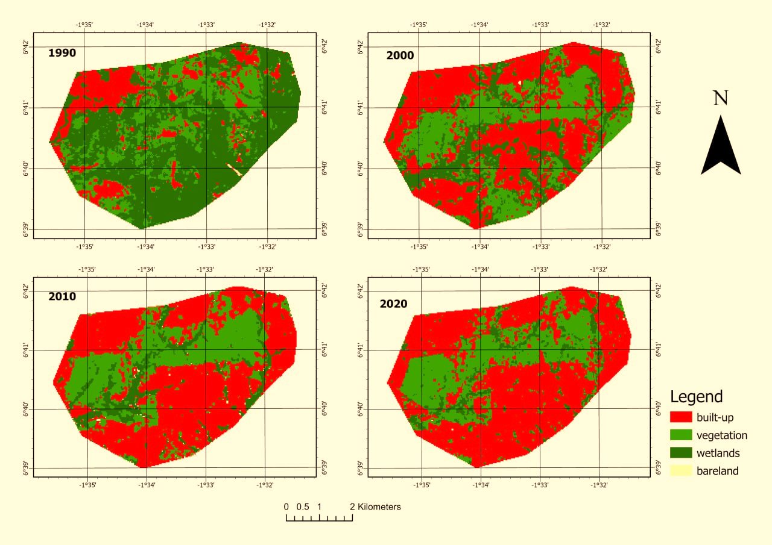

**Fig.2 Classified map of Land Use Changes in Kotei and Ayeduase for 1990, 2000, 2010, and 2020**

In contrast, the decade from 2010 to 2020 witnessed a more moderate increase of 7.37% in the built-up regions, taking the total to 1804.89 hectares by 2020. Vegetation zones, on the other hand, experienced a rise of 18.19% from 1990 to 2000 but saw a minor increase of just 1.32% by 2010. Notably, the period between 2010 and 2020 saw a slight reduction of 2.21% in these areas.

The wetlands exhibited a concerning decline over the years. Between 1990 and 2000, there was a sharp decrease of 63.91%, which continued with a 46.09% reduction up to 2010. The decade thereafter also saw a contraction, albeit at a slower rate of 26.37%, leaving only 242.84 hectares of wetlands by 2020. Lastly, barelands shrunk dramatically by 79.65% in the first decade, followed by a massive surge of 670.06% by 2010. However, this class saw a drastic decrease of 92.00% in the subsequent decade. Drawing insights from this data, one can infer that rapid urban development between 1990 and 2010 significantly reshaped the landscape.

**Change Detection Map**

Using satellite imagery and advanced geo-processing techniques, the study analyzed the landscape changes around KNUST, focusing on Kotei and Ayeduase, over three decades from 1990, 2000, 2010 to 2020 (See Figure 5). This study sheds light on the impact of KNUST's growth on local land use, highlighting the delicate balance between institutional expansion and environmental considerations.

1. **1990-2000:** The most striking observation from this period is the vast conversion of wetlands to built-up areas (626.15 hectares), suggesting a rapid urban expansion or establishment of infrastructural facilities, potentially in response to university expansion or population growth associated with KNUST. The wetlands saw other significant changes, transitioning into vegetation (605.15 hectares) or remaining as wetlands but undergoing alterations (460.44 hectares). The vegetation areas also showed notable shifts; while some were converted to built-up spaces (354.70 hectares), a considerable portion remained as vegetation, albeit with changes (270.14 hectares). The built-up areas themselves expanded by 440.25 hectares, possibly implying construction activities or infrastructural developments.
2. **2000-2010:** This decade saw an even more aggressive urban expansion. Built-up areas increased by a staggering 1202.87 hectares, and there was a noticeable encroachment on wetlands (231.53 hectares) and vegetation areas (243.08 hectares). The expansion of built-up zones into other land use categories indicates the possible proliferation of university-associated facilities, student housing, or other urban infrastructures. Vegetation areas also experienced considerable transformations. While some turned into built-up zones (199.61 hectares), a significant amount underwent internal changes (552.34 hectares).
3. **2010-2020:** The transformation momentum continues, with built-up areas expanding by an impressive 1564.95 hectares. Interestingly, while built-up zones continued to encroach on vegetation (168.03 hectares) and wetlands (59.13 hectares), the rate was slower than in the previous decade. This might indicate the onset of saturation or stricter land-use regulations in response to the environmental implications of rapid urbanization. The wetlands continued to face pressures, converting to built-up zones (34.69 hectares) or vegetation (84.76 hectares).

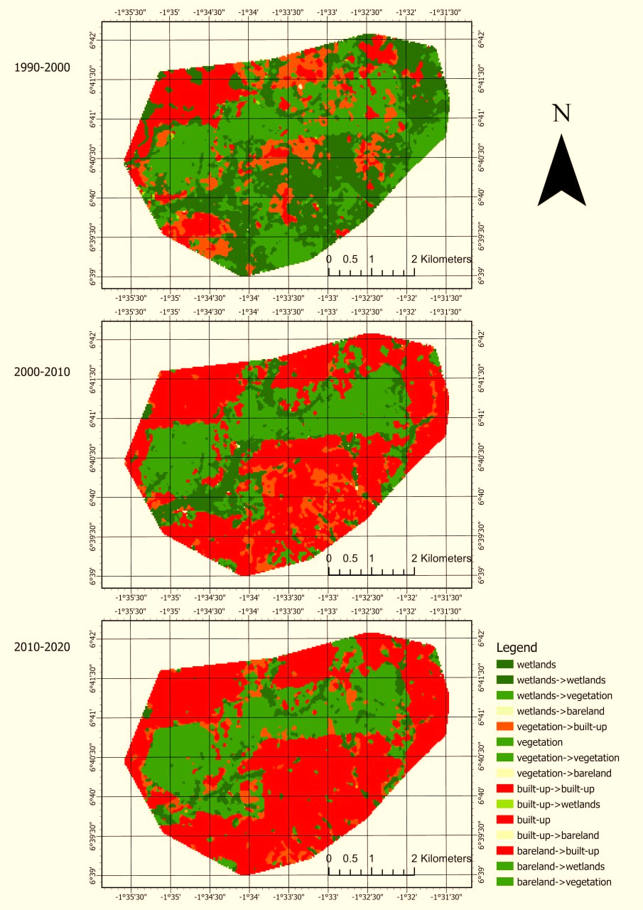

**Fig.3 Change Detection for the Study Area**

1. **Implications & Context:** KNUST, as an expanding educational institution, might have indirectly or directly influenced these land use changes through its growth needs, leading to increased infrastructure development, student accommodations, and other facilities.

**Fig.4 Trends of Impact of the Land Use Classes**

**Fig.5 A Graph of Land Use Classes**

In 1990, the chart shows that the largest land use category is "vegetation," followed by "built-up areas" and "wetlands." This suggests that the area was primarily covered by natural vegetation at the beginning of the analyzed period, with a relatively smaller portion dedicated to built-up areas and wetlands. By 2000, there was a noticeable increase in the "built-up areas" category, indicating significant urban development or construction during this decade. The "vegetation" category appears to have decreased slightly, possibly due to land conversion for construction. In 2010, there was a substantial decline in the "wetlands" category, suggesting that wetland areas may have been converted for other uses, possibly urban or agricultural. The "built-up areas" category continues to grow, indicating ongoing urbanization and development. By 2020, the chart shows a further increase in the "built-up areas" category, indicating continued urban expansion. The "vegetation" category also appears to have decreased, possibly due to further land conversion for development. The analysis of these charts indicates a clear trend of urbanization and land development over the analyzed period (1990-2020). There is a noticeable shift from natural vegetation and wetlands towards increased built-up areas. This suggests rapid urban growth and development in the region, which shows there are land use changes over time.

**Student Population Dynamics and Land Use Transformations**

The relationship between student population dynamics and its subsequent impact on land use changes is an area of crucial significance, especially within academic environments experiencing exponential growth like KNUST. The provided dataset gives a chronological representation of land use changes and student population growth from 1990,2000,2010 to 2020. Using this data, a predictive model was generated to visualize and understand the impacts (See Fig.4.8).

1. **1990-2000:** During this period, there was an increase of 949.32 hectares in land use, accompanied by a population growth of 7,000 students. The positive land use change suggests that expansion initiatives could have been undertaken to accommodate the growing student population. This could include the development of new faculties, student housing, or recreational areas.

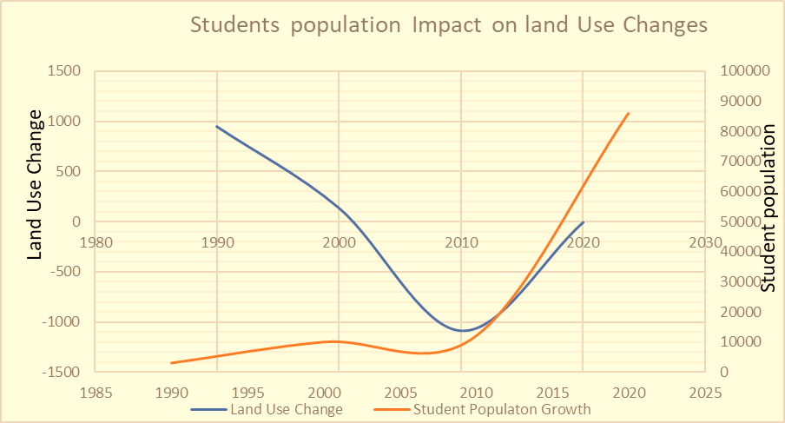

**Fig.6 Conceptual Predictive Model on Student Population Effects on Land Use Changes**

1. **2000-2010:** This decade witnessed a slightly lower positive change in land use (138.72 hectares) even though there was a significant increase in the student population (an additional 2,000 students). The disproportionate change suggests optimized land use, potential vertical expansion (e.g., multi-story buildings), or perhaps the university began facing land constraints.
2. **2010-2020:** The most notable period is this last decade, which saw a sharp decline in land use by 1083.93 hectares in 2010, followed by a minimal decrease in 2020. Conversely, the student population surged significantly by 74,000. The steep decline in land use in 2010 could indicate a strategic move like reallocating land for ecological conservation, transferring land for other purposes, or a potential data inconsistency. The huge increase in the student population without corresponding land expansion suggests increased density, improved space management, and potentially the rise of off-campus accommodations.

**Socio-Economic Effects**

Our investigation into the socio-economic consequences of land use change and population dynamics within the context of Kotei and Ayeduase, with responses from a diverse group of stakeholders, highlights the intricate impacts experienced in these communities. Across five key participants, these findings illuminate the complex interplay between economic development, cultural heritage, livelihoods, and urbanization. The study focused on interview, with the Assembly Man of Ayeduase,The Assembly Man highlighted that;

*“Over the years, there has been a significant transformation in our communities. The rapid expansion of KNUST and the student population has brought both opportunities and challenges. While there's increased economic activity, the traditional character and essence of our towns are fading."*

His comments reflect the dual nature of development, where economic progress comes at the cost of cultural heritage. Also, a native of Kotei expressed concern, stating;

“*Our ancestral lands, once dominated by farms and green spaces, have now given way to hostels and commercial buildings. This has influenced our younger generation to move towards urbanized lifestyles, often at the expense of our cultural heritage."*

This sentiment underscores the cultural and generational shifts triggered by land use changes. A farmer also shared,

*“Land use change has deeply affected our farming practices. With shrinking agricultural land, many farmers have been pushed to the fringes or forced to abandon farming. While some have found alternative sources of income, others struggle to make ends meet."*

This emphasizes the direct impact on livelihoods, especially in the agricultural sector. A worker at KNUST noted;

*“The university's growth has led to job opportunities, especially in the services sector. However, the cost of living has also risen, making it challenging for many workers to sustain their families."*

This comment highlights the complex economic interplay, where job opportunities are coupled with increased living expenses. During an interview session a resident shared;

“*The influx of students has led to a boom in housing, food joints, and entertainment spots. But on the downside, Ayeduase often feels overcrowded, and rents have skyrocketed in recent years."*

Their comments illuminate the immediate impacts of student population growth on the local economy and housing market.

A Resident in Ayeduase voiced concerns, stating,

*“Our once quiet and serene community has transformed into a bustling hub. While we benefit from improved amenities, there's a sense of lost community spirit. Traffic congestion, noise, and waste management have become pressing issues."*

These remarks underscore the social and environmental challenges brought about by urbanization. A hostel porter provided insights, saying;

” *The surge in student population has led to a high demand for accommodation. This has been good for business, but it also means more management challenges. There's a need for regular maintenance, security, and ensuring the well-being of students."*

This perspective sheds light on the economic opportunities within the service sector but also highlights the responsibilities associated with catering to a growing student community. These findings underscore the multifaceted nature of the socio-economic consequences arising from land use changes and population dynamics. While economic opportunities and job creation have emerged as positive outcomes, there are also challenges associated with cultural heritage preservation, resource strain, and environmental degradation. Striking a balance between growth and preservation is essential for the long-term well-being of these communities. The insights gathered from local stakeholders underscore the need for sustainable and inclusive development strategies that account for both economic aspirations and socio-cultural preservation in the face of evolving urbanization and institutional expansion.

# DISCUSSION

In this discussion, the study delves into the findings, implications, and the broader context of these objectives, shedding light on the intricate relationship between land use transformations, population dynamics, and socio-economic outcomes within the study area of Kotei and Ayeduase.

**Analyzing Land Use Changes**

The meticulous mapping and analysis of land use changes over three decades have unveiled significant shifts in the landscape of Kotei and Ayeduase. From 1990 to 2000, the built-up areas saw an astonishing surge of 199.01%, indicative of rapid urbanization and settlement expansion, likely attributed to population growth. This trend continued, albeit at a slower pace, in the subsequent decade (2000-2010), with a 17.78% increase. The final decade (2010-2020) displayed a more moderate growth rate of 7.37%, bringing the total built-up area to 1804.89 hectares by 2020. In contrast, vegetation zones experienced an 18.19% rise from 1990 to 2000 but witnessed a minor increase of just 1.32% by 2010. However, the period between 2010 and 2020 saw a slight reduction of 2.21% in these areas.

The wetlands, crucial ecological features, exhibited a concerning decline throughout the study period. Between 1990 and 2000, there was a sharp decrease of 63.91%, followed by a 46.09% reduction up to 2010. The subsequent decade witnessed a slower contraction of 26.37%, leaving only 242.84 hectares of wetlands by 2020. Barelands, characterized by significant fluctuations, shrank dramatically by 79.65% in the first decade, followed by a massive surge of 670.06% by 2010. However, this class saw a drastic decrease of 92.00% in the subsequent decade. These changes underscore the transformative impact of rapid urban development, particularly in the depletion of wetlands.

**Student Population Dynamics and Land Use Changes**

The interplay between student population dynamics and land use transformations unveils nuanced patterns. From 1990 to 2000, land use increased by 949.32 hectares, accompanied by a 7,000-student population growth, indicating infrastructure development to accommodate the rising student numbers. In contrast, during the period from 2000 to 2010, a slightly lower land use change of 138.72 hectares was observed despite a significant increase of 2,000 students, suggesting optimized land use or potential land constraints. The most notable period was from 2010 to 2020, marked by a sharp decline in land use (1083.93 hectares) but a substantial increase of 74,000 students. This suggests increased density, improved space management, and the emergence of off-campus accommodations, potentially driven by conservation efforts or land reallocation.

**Assessing Socio-Economic Consequences**

Our investigation into the socio-economic consequences of these changes involved engaging a diverse group of stakeholders, including local leaders, natives, farmers, workers, students, residents, and hostel porters. The responses from these participants collectively underscore the multifaceted nature of these consequences. Economic opportunities and job creation emerged as positive outcomes. Still, challenges related to cultural heritage preservation, resource strain, and environmental degradation were also evident. The transformation of once quiet and serene communities into bustling hubs, accompanied by issues like traffic congestion, noise, and waste management, underscores the social and environmental challenges brought about by urbanization.

**Implications and Sustainable Development:**

The findings from this study emphasize the need for sustainable and inclusive development strategies that carefully balance economic growth with socio-cultural preservation. In the context of KNUST's expansion and the associated urbanization, it is imperative to consider not only economic aspirations but also the preservation of cultural heritage and environmental sustainability. The insights gathered from a total of five key participants provide a holistic view of the challenges and opportunities faced by these communities in the wake of ongoing transformations.

# CONCLUSION AND RECOMMENDATION

This research underscores the intricate relationship between land use changes, student population dynamics, and socio-economic consequences in the study area. The findings have provided valuable insights into the transformation of Kotei and Ayeduase over three decades. It is evident that urbanization and institutional expansion, driven by factors such as population growth and university development, have significantly shaped the local landscape. As wetlands shrink and built-up areas rise, the implications are multi-fold: loss of biodiversity, changes in micro-climate, and increased vulnerability to flooding due to the reduction of natural water absorption zones . This rapid urbanization and loss of green spaces also imply a greater need for urban planning and sustainable practices, especially in a university context. The consequences of these changes are multifaceted. While economic opportunities and job creation have emerged as positive outcomes, there are also challenges associated with cultural heritage preservation, resource strain, and environmental degradation. The shrinking of wetlands and the expansion of built-up areas raise concerns about biodiversity loss and increased vulnerability to flooding.

These findings highlight the need for sustainable and inclusive development strategies that carefully balance economic growth with socio-cultural preservation and environmental sustainability. Local authorities should prioritize sustainable urban planning practices that consider the long-term ecological and socio-cultural impacts of land use changes. This includes implementing land-use regulations that protect wetlands and green spaces while encouraging responsible urban development. Efforts should be made to protect and conserve wetland areas, which play a crucial role in maintaining biodiversity and mitigating flooding. Conservation initiatives, such as wetland restoration and protected areas, should be explored. Engaging with local communities, including natives and residents, is essential in decision-making processes related to urbanization and land use changes. Their perspectives and concerns should be integrated into development plans. The university and local authorities should invest in infrastructure development that accommodates the growing student population while minimizing the environmental footprint. This could include the construction of eco-friendly buildings and improved waste management systems. Continued research and monitoring of land use changes, population dynamics, and their socio-economic consequences are essential. This will enable evidence-based decision-making and adaptive strategies as the region continues to evolve.

# ACKNOWLEDGEMENT

I want to thank the many people who help in the data collection and processing of the study. I will also want to thank the reviewers of the work.

# REFERENCES

Abass, K., Appiah, D. O., & Afriyie, K. (2019). Does green space matter? Public knowledge and attitude towards urban greenery in Ghana. *Urban Forestry & Urban Greening*, *46*, 126462. https://doi.org/10.1016/J.UFUG.2019.126462

Addie, J. P. D., Keil, R., & Olds, K. (2015). Beyond Town and Gown: Universities, Territoriality and the Mobilization of New Urban Structures in Canada. *Territory, Politics, Governance*, *3*(1), 27–50. https://doi.org/10.1080/21622671.2014.924875.

Bernard, H. R. (2013). *Social research methods: Qualitative and quantitative approaches*. Sage.

Butt, A. (2013). Functional Change and the Peri-Urban Region: Food Systems and Agricultural Vulnerability. *Economic Papers: A Journal of Applied Economics and Policy*, *32*(3), 308–316. https://doi.org/10.1111/1759-3441.12045

Casana, J. (2020). Global-Scale Archaeological Prospection using CORONA Satellite Imagery: Automated, Crowd-Sourced, and Expert-led Approaches. *Journal of Field Archaeology*, *45*(sup1), S89–S100. https://doi.org/10.1080/00934690.2020.1713285

Iddrisu, S., Siiba, A., Alhassan, J., & Abass, K. (2023). Land-use and land cover change dynamics in urban Ghana: implications for peri-urban livelihoods. *International Journal of Urban Sustainable Development*, *15*(1), 80–96. https://doi.org/10.1080/19463138.2023.2184822

Korah, P. I., Cobbinah, P. B., Nunbogu, A. M., & Gyogluu, S. (2017). Spatial plans and urban development trajectory in kumasi, Ghana. *GeoJournal*, *82*(6), 1113–1134. https://doi.org/10.1007/S10708-016-9731-1/METRICS

Lambin, E. F., Turner, B. L., Geist, H. J., Agbola, S. B., Angelsen, A., Bruce, J. W., Coomes, O. T., Dirzo, R., Fischer, G., Folke, C., George, P. S., Homewood, K., Imbernon, J., Leemans, R., Li, X., Moran, E. F., Mortimore, M., Ramakrishnan, P. S., Richards, J. F., … Xu, J. (2001). The causes of land-use and land-cover change: moving beyond the myths. *Global Environmental Change*, *11*(4), 261–269. https://doi.org/10.1016/S0959-3780(01)00007-3

Liping, C., Yujun, S., & Saeed, S. (2018). Monitoring and predicting land use and land cover changes using remote sensing and GIS techniques—A case study of a hilly area, Jiangle, China. *PLOS ONE*, *13*(7), e0200493. https://doi.org/10.1371/JOURNAL.PONE.0200493

McCusker, B., & Carr, E. R. (2006). The co-production of livelihoods and land use change: Case studies from South Africa and Ghana. *Geoforum*, *37*(5), 790–804. https://doi.org/10.1016/J.GEOFORUM.2005.09.007

Puppim de Oliveira, J. A., Balaban, O., Doll, C. N. H., Moreno-Peñaranda, R., Gasparatos, A., Iossifova, D., & Suwa, A. (2011). Cities and biodiversity: Perspectives and governance challenges for implementing the convention on biological diversity (CBD) at the city level. *Biological Conservation*, *144*(5), 1302–1313. https://doi.org/10.1016/J.BIOCON.2010.12.007

Ross, M. L., Kaiser, K., & Mazaheri, N. (2017). *The"Resource Curse"In MENA? Political Transitions, Resource Wealth, Economic Shocks, and Conflict Risk*. http://www.zbw.eu/econis-archiv/handle/11159/121859

Shen, J. (2022). Universities as financing vehicles of (sub)urbanisation: the development of university towns in Shanghai. *Land Use Policy*, *112*, 104679. https://doi.org/10.1016/J.LANDUSEPOL.2020.104679

Teig, E., Amulya, J., Bardwell, L., Buchenau, M., Marshall, J. A., & Litt, J. S. (2009). Collective efficacy in Denver, Colorado: Strengthening neighborhoods and health through community gardens. *Health & Place*, *15*(4), 1115–1122. https://doi.org/10.1016/J.HEALTHPLACE.2009.06.003

Tschakert, P., Tutu, R., & Alcaro, A. (2013). Embodied experiences of environmental and climatic changes in landscapes of everyday life in Ghana. *Emotion, Space and Society*, *7*(1), 13–25. https://doi.org/10.1016/J.EMOSPA.2011.11.001